**6225-CSYE Network Structures and Cloud Computing**

Cloud Computing Project

Report

Priyanka Bandekar

Maansi Chandira

Geetesh Pandit

Siddharth Wale

***By : Prof. Julian Cooper***

**Table of Contents**

|  |  |
| --- | --- |
| **1.** | **Introduction** |
| **2.** | **Overview** |
| **3.** | **Requirements** |
| **4.** | **Business Justification** |
| **5.** | **Systems and Descriptions**   * **Techniques Used** * **Platform** * **Web application** * **User simulation** * **Launching an instance using Elastic Bean Stalk** * **Attaching SSL Certificate** * **Amazon RDS** * **Amazon S3** * **CloudWatch** |
| **6.** | **Cloud pricing model for the next 3-6 months (Cost Vs Performance)** |
| **7.** | **Visio Diagram and Flow** |
| **8.** | **Disaster Recovery** |

**Introduction**

**Cloud computing** is a type of [Internet](https://en.wikipedia.org/wiki/Internet)-based computing that provides shared computer processing resources and data to computers and other devices on demand. It is a model for enabling ubiquitous, on-demand access to a shared pool of configurable computing resources (e.g., computer networks, servers, storage, applications and services),which can be rapidly provisioned and released with minimal management effort. Cloud computing and storage solutions provide users and enterprises with various capabilities to store and process their data in third-party [data centers](https://en.wikipedia.org/wiki/Data_center) that may be located far from the user–ranging in distance from across a city to across the world. Cloud computing relies on sharing of resources to achieve coherence and [economy of scale](https://en.wikipedia.org/wiki/Economies_of_scale), similar to a utility (like the [electricity grid](https://en.wikipedia.org/wiki/Electrical_grid)) over an electricity network.

**Amazon Web Services** is a collection of remote computing services that together make up a cloud computing platform, offered over internet by amazon.com. Amazon Elastic Compute Cloud (Amazon EC2) is a web service that provides resizable compute capacity in the cloud. It is designed to make web-scale cloud computing easier for developers.

**AWS Elastic Beanstalk** is an easy-to-use service for deploying and scaling web applications and services developed with Java, [.NET](https://aws.amazon.com/net/), PHP, Node.js, Python, Ruby, Go, and [Docker](https://aws.amazon.com/docker/) on familiar servers. You can simply upload your code and Elastic Beanstalk automatically handles the deployment, from capacity provisioning, load balancing, auto-scaling to application health monitoring. At the same time, you retain full control over the AWS resources powering your application and can access the underlying resources at any time.

**Overview**

We have created a Car Rental Web Application where in Customers can register and create an account. After creating an account, user can login to the portal and reserve cars for rent. There is one Admin role who can create and update cars for rent. Admin can insert all the features and even upload a photo of the car.

The web application is deployed using Elastic Beanstalk. Data was generated randomly with 2000 Records. Customers can reserve a car for rent on the portal wherein the image of the car are stored in the s3 bucket in AWS through Hibernate.

**Requirements**

1. Develop a login portal using Java Spring which will consist of use-case buttons to simulate an increasing load on the application and database.
2. The database can either be a relational database or a NoSQL database.
3. The entire stack must be deployed in AWS or Azure.
4. Proper infrastructure alerts and triggers to allow for auto-scaling of resources to accommodate the additional load in application, network, data storage and usage with your environment.
5. Minimum of one load balancer is required.
6. There are 5 use-case buttons that need to be implemented which are follows:
   1. Simulation of 3 user login to application and run 2 report going back 10 days
   2. Simulation of 10 user login to application and run 6 report going back 30 days
   3. Simulation of 17 user login to application and run 10 report going back 60 days
   4. Simulation of 24 user login to application and run 14 report going back 90 days.
   5. User input fields to allow me the ability to enter parameters for how many users login simulation and how many reports those users are uniquely are running.

**Business Justification**

**Develop** and **Deploy** a web application that simulates workloads on servers and scale them accordingly using AWS.

Simulate the web application on EC2 Instance and configure it to connect to RDS for MySQL database Instance.

Develop 5 use case buttons to simulate increasing load on the application using Java Spring MVC framework.

**Systems and Descriptions**

* **Techniques Used**
* Load balancing
* Auto Scaling
* CloudWatch
* **Platform**

Amazon Web Services

* **Web Application:**

We have created a Car Rental Web Application where in Customers can register and create an account. After creating an account, user can login to the portal and reserve cars for rent. Used MySQL with RDS as Database.

A report page is view data about the Cars in the database. Besides the main report we have a mechanism to simulate users.

* **User Simulation**

We are using a python script to create a web client, which will open a socket connection to the server and request a web page from the application. When we use any of the buttons on the report page to simulate user requests to the application, the web application creates a process to execute the python script using a UNIX command. Depending on the value of user count being simulated, the script opens that many connections to the server and tries to fetch data.

* **Launching instance using Elastic Beanstalk**

Elastic beanstalk contains preconfigured platform. It automatically handles the deployment, from capacity provisioning, load balancing, auto-scaling to application health monitoring. The war file of web application is uploaded. It creates own security groups, adds an instance to the environment and t1 micro instance in EC2. Instance is now created.

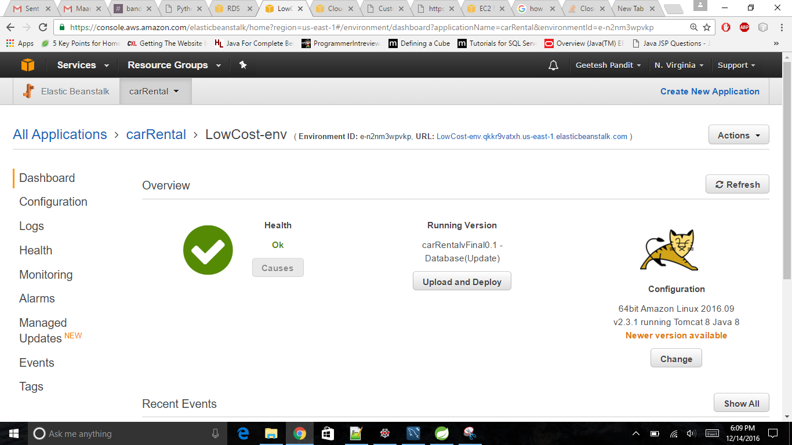

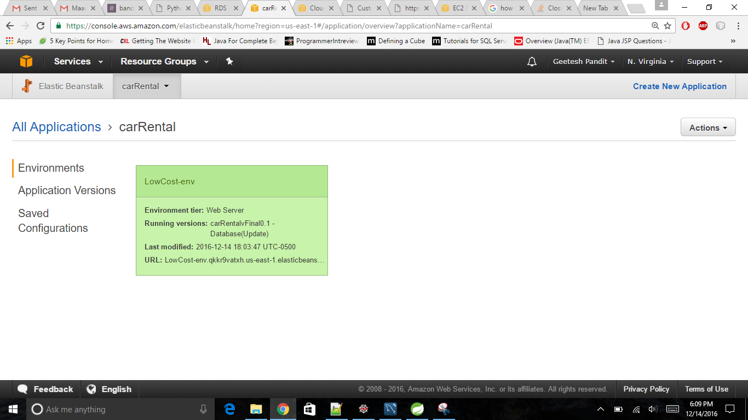

* **Attaching SSL Certificate to Load Balancer**

Load Balancing improves the distribution of [workloads](https://en.wikipedia.org/wiki/Workload) across multiple computing resources. It aims to optimize resource use, maximize [throughput](https://en.wikipedia.org/wiki/Throughput), minimize response time, and avoid overload of any single resource.

We added SSL certificate on the load balancer to forward all the requests to HTTPS on port (443)

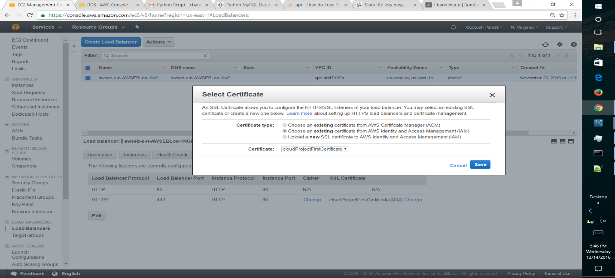

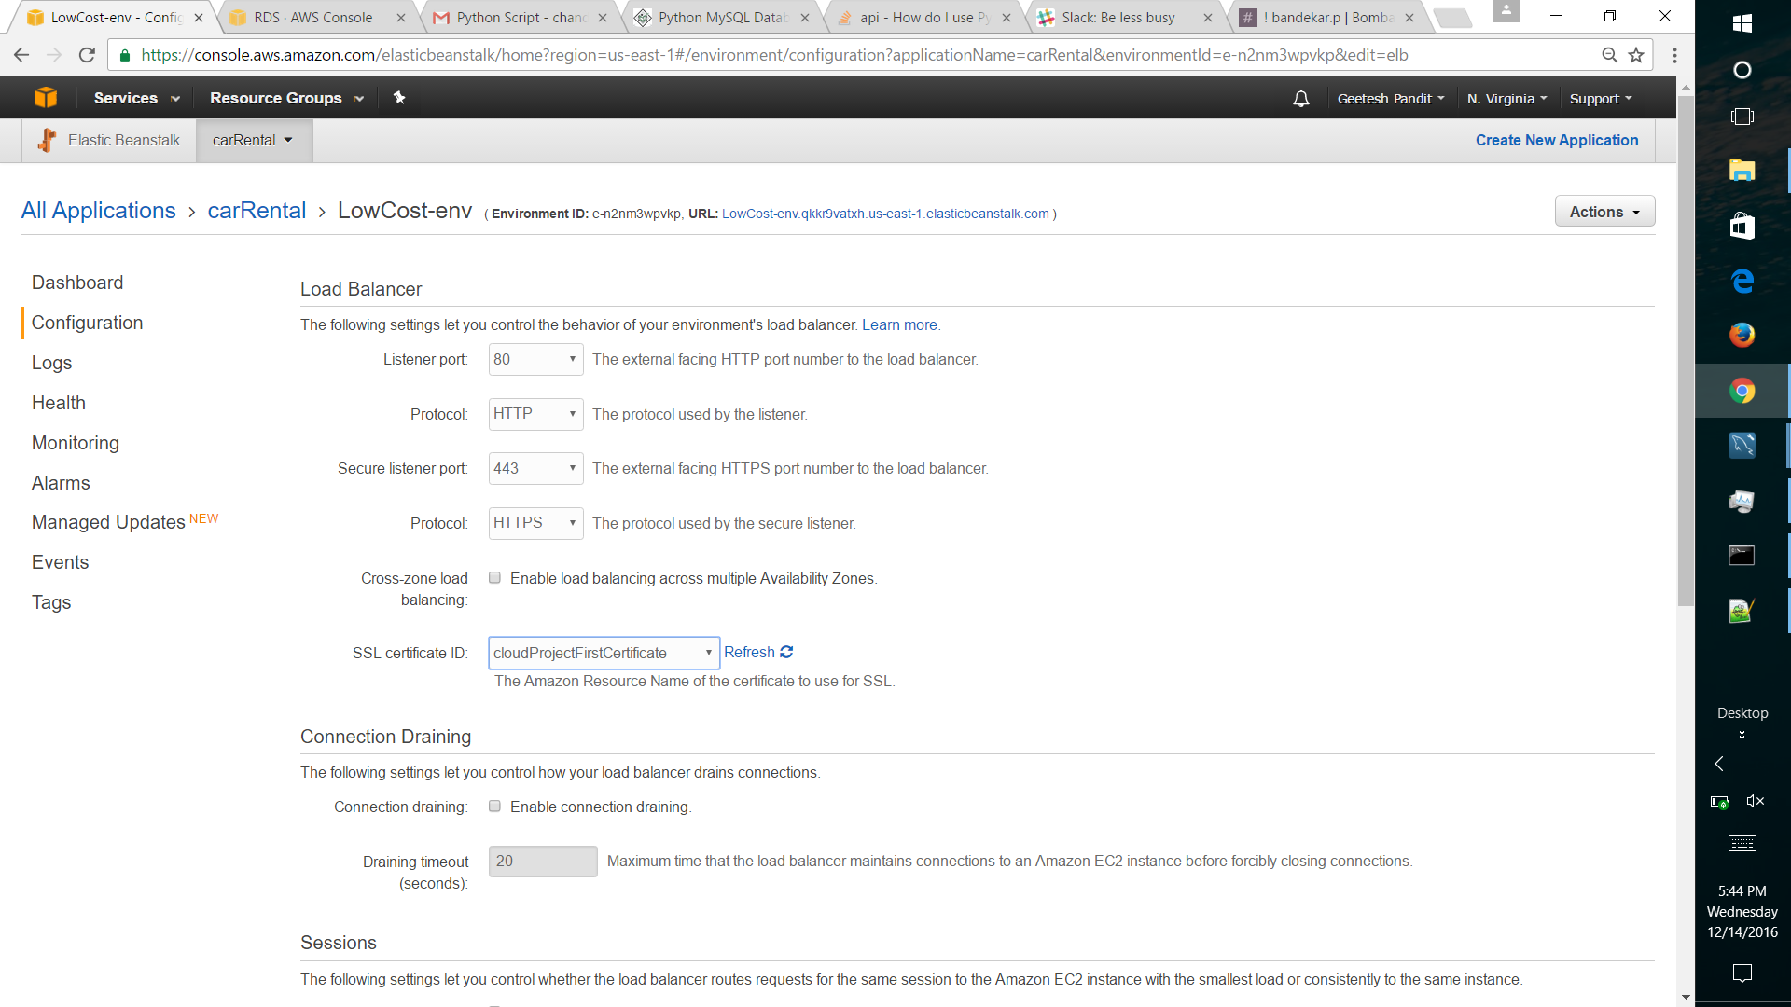

Elastic Beanstalk configuration file to override default EBS settings to redirect all the HTTP requests to HTTPS

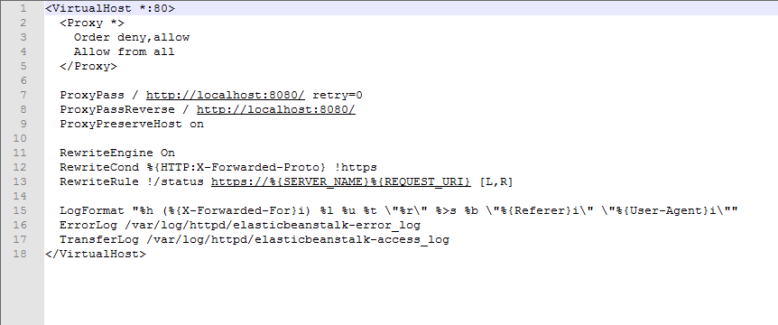

* **Amazon RDS**

Amazon Relational Database Service (Amazon RDS) makes it easy to set up, operate, and scale a [relational database](https://aws.amazon.com/relational-database/) in the cloud.

It provides cost-efficient and resizable capacity while managing time-consuming database administration tasks, freeing you up to focus on your applications and business.

We have used RDS for MySQL Database Instance to fetch the data for our Application. Amazon RDS for MySQL gives access to the capabilities of a familiar MySQL database engine.

We have also created a replica of RDS in case if we want to restore or migrate the database.

First we created a db instance.

The DB is created below along with the replica:

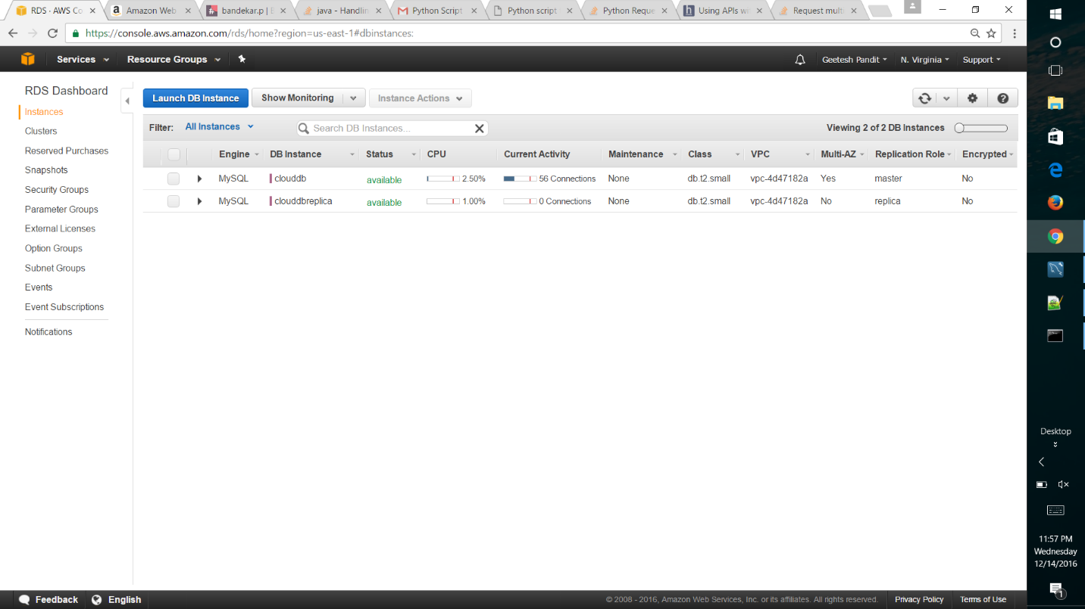

We connected the RDS instance with MySQL database connection. We specified the end point URL of the DB instance with username and password that was used during launching of the DB instance.

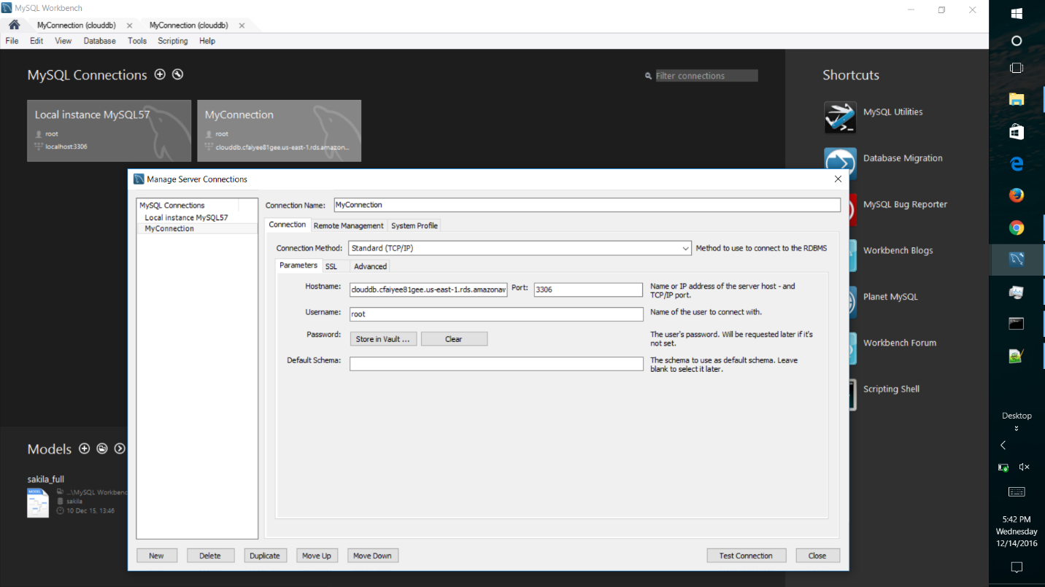

RDS Utlization Graphs:

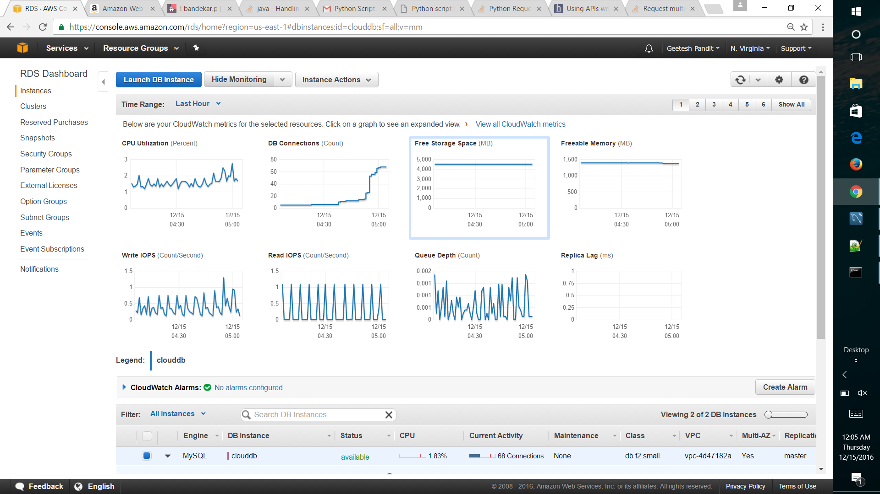

* **Amazon S3**

Amazon Simple Storage Service (Amazon S3) is object storage with a simple web service interface to store and retrieve any amount of data from anywhere on the web

In Our Architecture we have created a S3 bucket wherein images are uploaded to it from our application.

3 types of S3 buckets are available that is S3 Standard (frequently used), S3 Standard (infrequently used) and Amazon Glaciers.

We have used Standard frequently used S3 bucket which has 5GB standard storage.

S3 replicates data on multiple devices automatically in different availability zones.

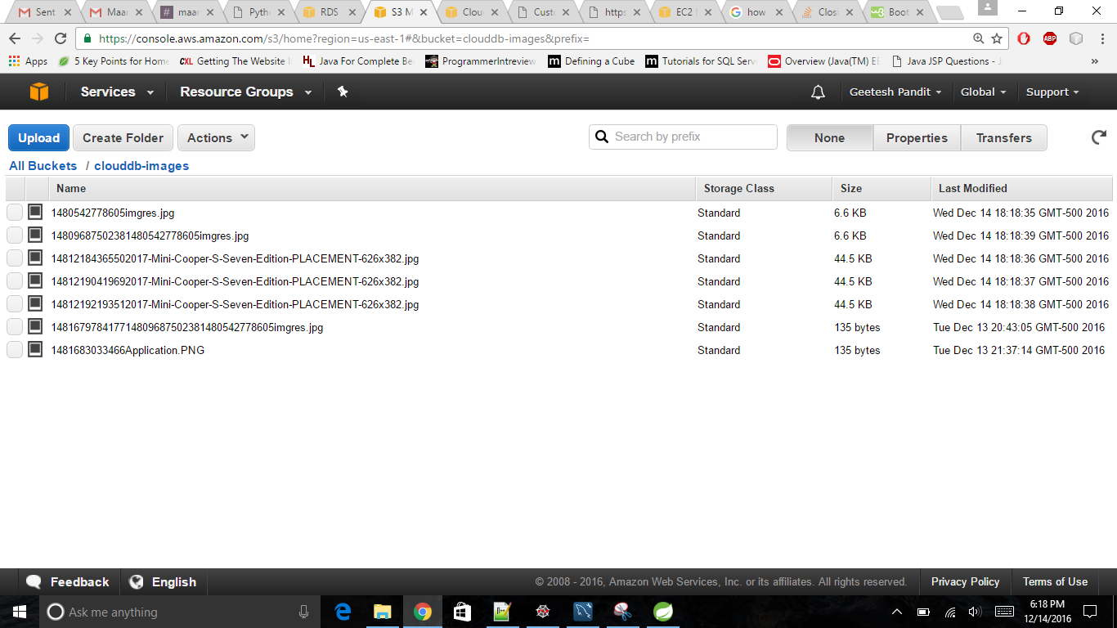

* **Auto Scaling:**

Auto Scaling helps you maintain application availability and allows you to scale your [Amazon EC2](https://aws.amazon.com/ec2/) capacity up or down automatically according to conditions you define. You can use Auto Scaling to help ensure that you are running your desired number of Amazon EC2 instances. Auto Scaling can also automatically increase the number of Amazon EC2 instances during demand spikes to maintain performance and decrease capacity during lulls to reduce costs.

In our project we have used AWS Elastic Beanstalk which handles the auto scaling feature itself. We then use Cloud Watch to monitor our server(s) instance(s), and when certain events happen (i.e. events that can trigger an alarm like CPU utilization or DiskWriteOps), we can launch/decrease instances based on the template we define in EBS. The EC2 instances are launched behind the Elastic Load Balancer (ELB) we define. The ELB will send traffic in a round-robin pattern between all the instances assigned to it, and we can control in real time how many instances we want to launch to cover traffic (high and low). If any of the EC2 instances fails to respond, the ELB will detect it and launch a replacement. When web traffic dies down, instances can be terminated automatically.

Scale up:

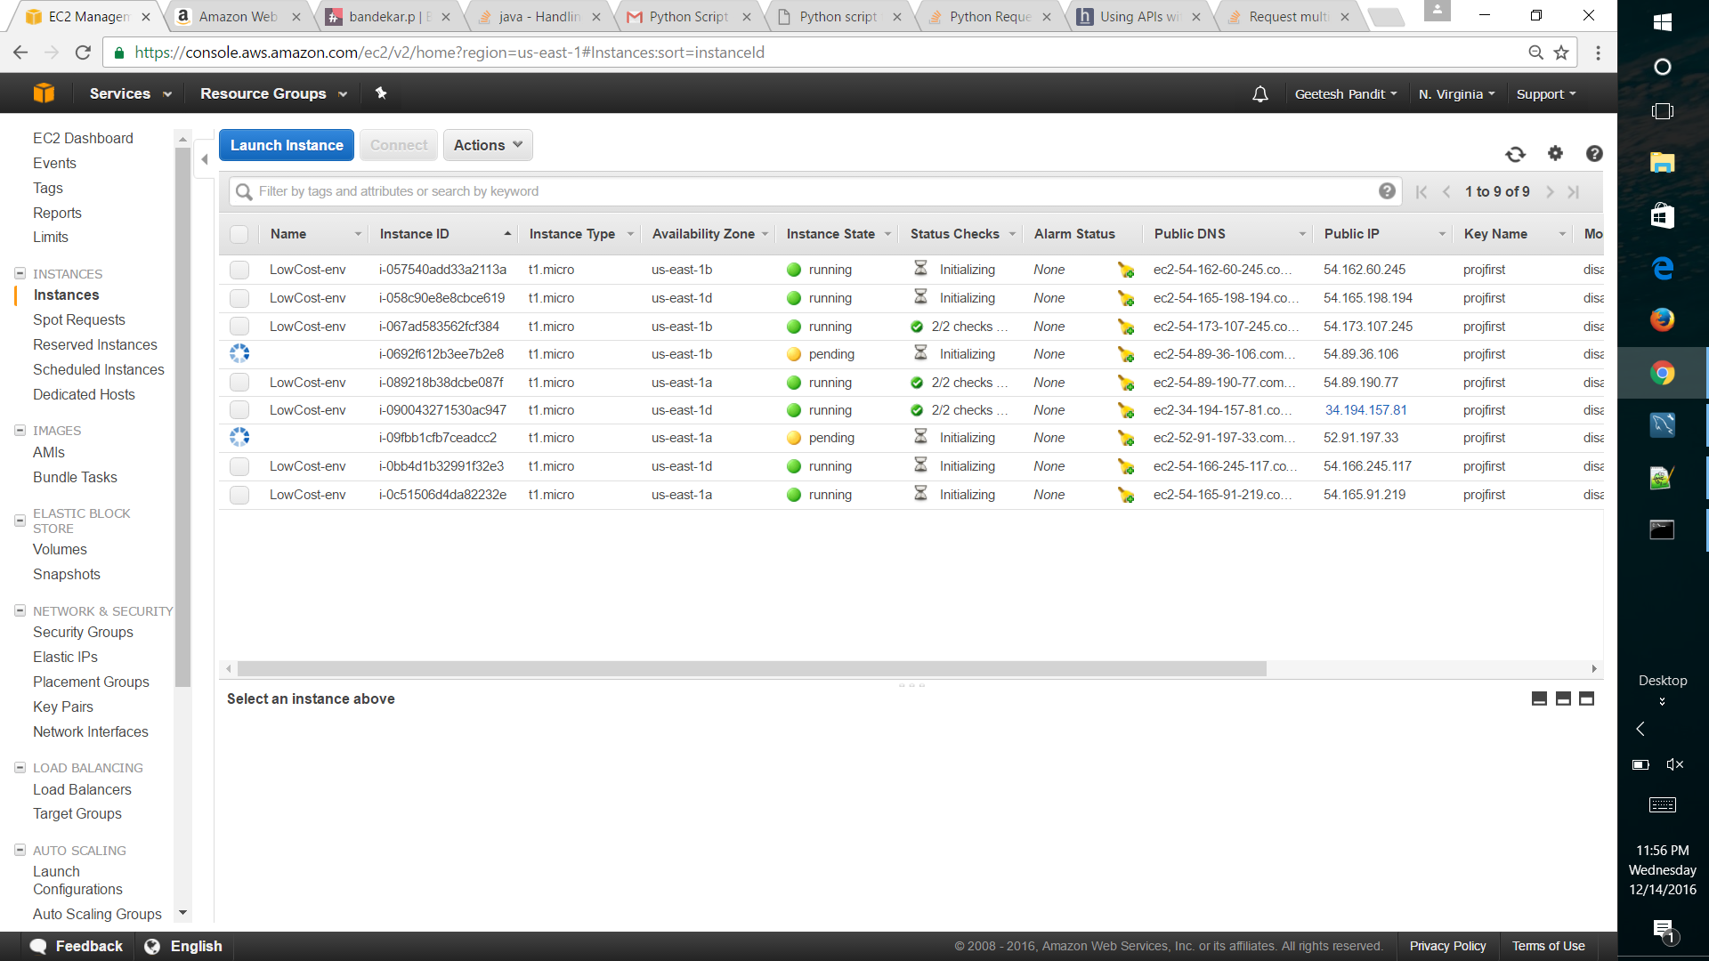

Scale Down:

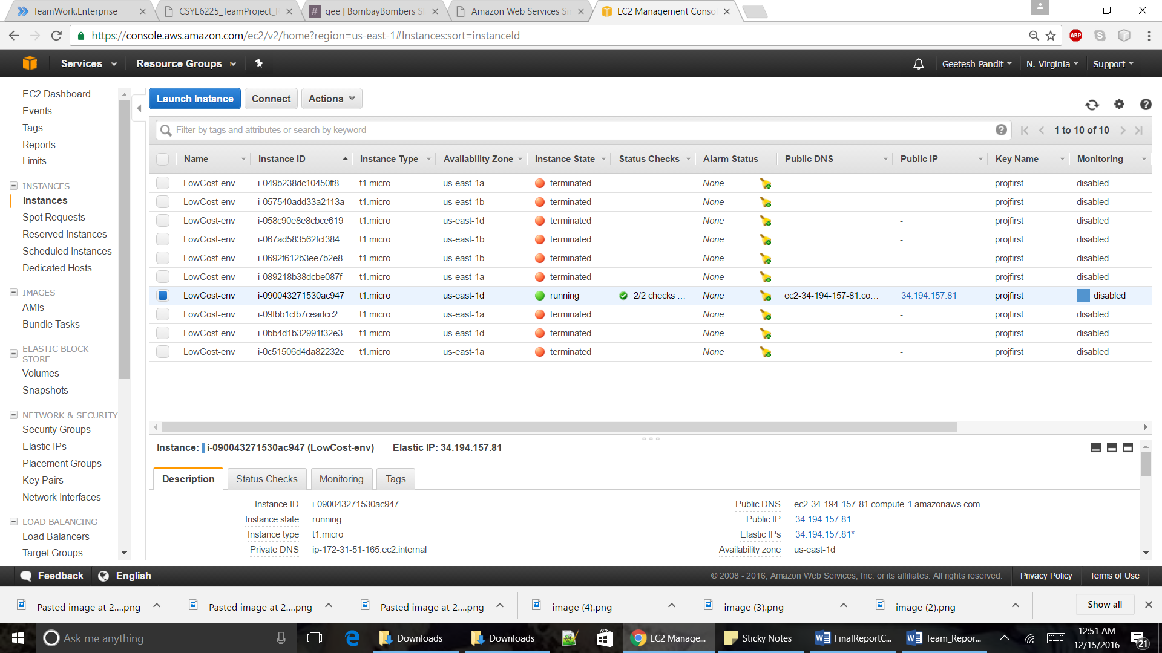

* **CloudWatch**

Amazon CloudWatch is a monitoring service for AWS cloud resources and the applications you run on AWS. You can use Amazon CloudWatch to collect and track metrics, collect and monitor log files, set alarms, and automatically react to changes in your AWS resources. You can use Amazon CloudWatch to gain system-wide visibility into resource utilization, application performance, and operational health.

In our project we have used Amazon CloudWatch to monitor AWS resources such as Amazon EC2 instances and Amazon RDS DB instances, as well as custom metrics generated by your applications and services, and any log files your applications generate.

Cloud watch works with the help of alarms.

An alarm can have three possible states.

• OK—The metric is within the defined threshold

• ALARM—The metric is outside of the defined threshold

•INSUFFICIENT_DATA—The alarm has just started, the metric is not available, or not enough data is available for the metric to determine the alarm state.

For our application we have set 2 alarms to trigger. We have chosen the CPU utilization metrics from EC2.

1. If the CPU utilization is > 90% for 1 mins and number of requests > 50 then the auto scaling group will automatically scale up by an instance.

2. If the CPU utilization is < 5% and number of requests <5 for 5 mins then the auto scaling group will automatically scale down by an instance.

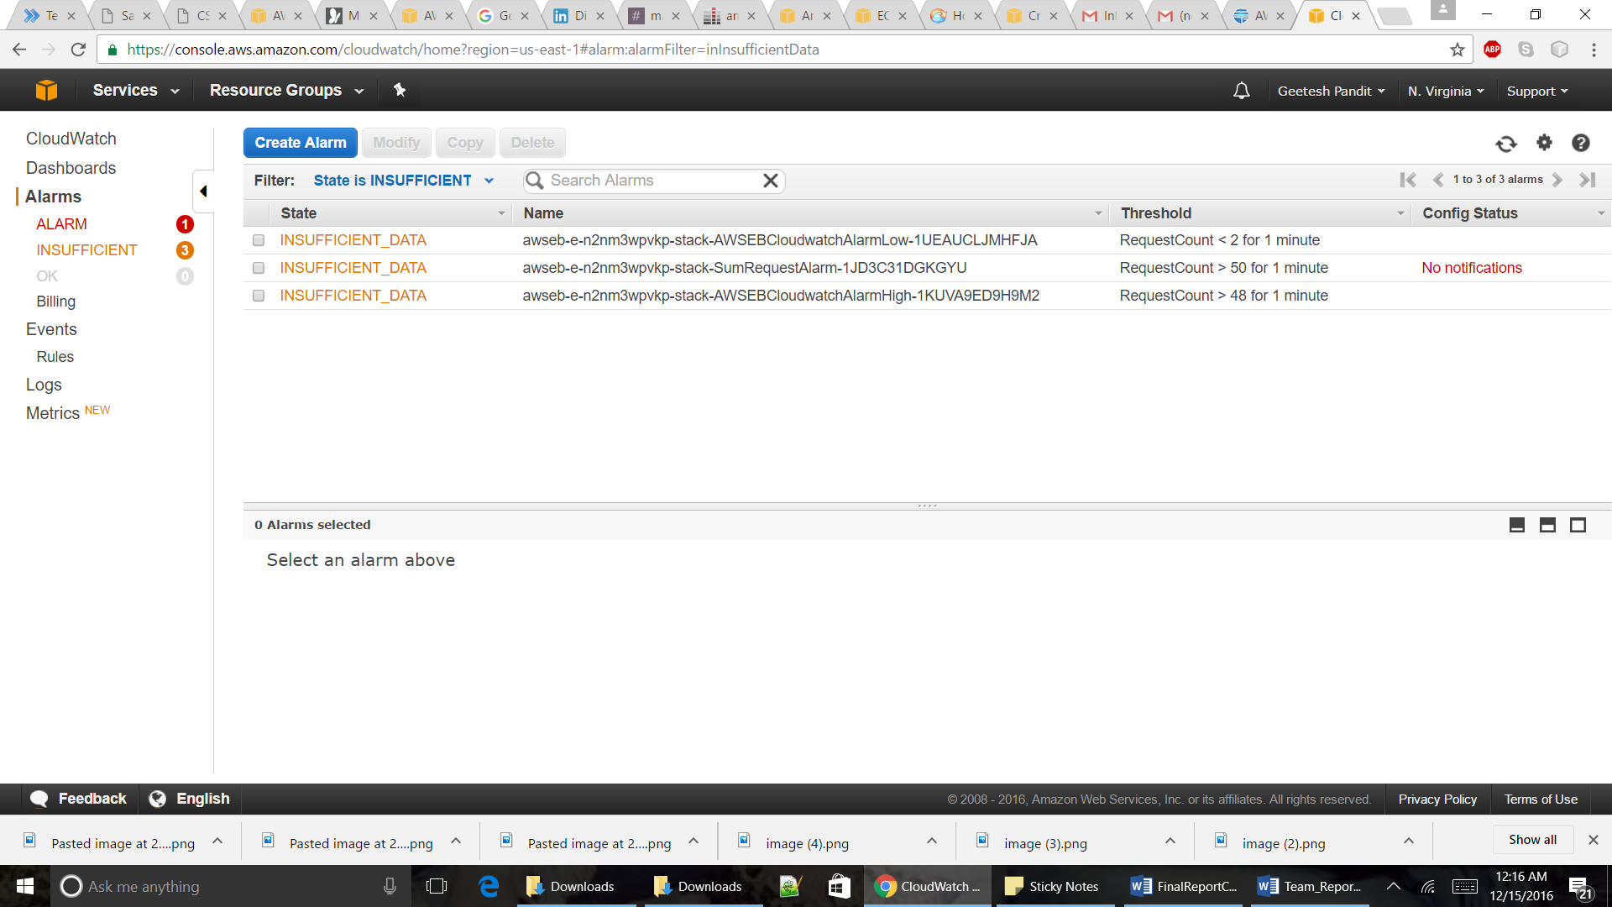

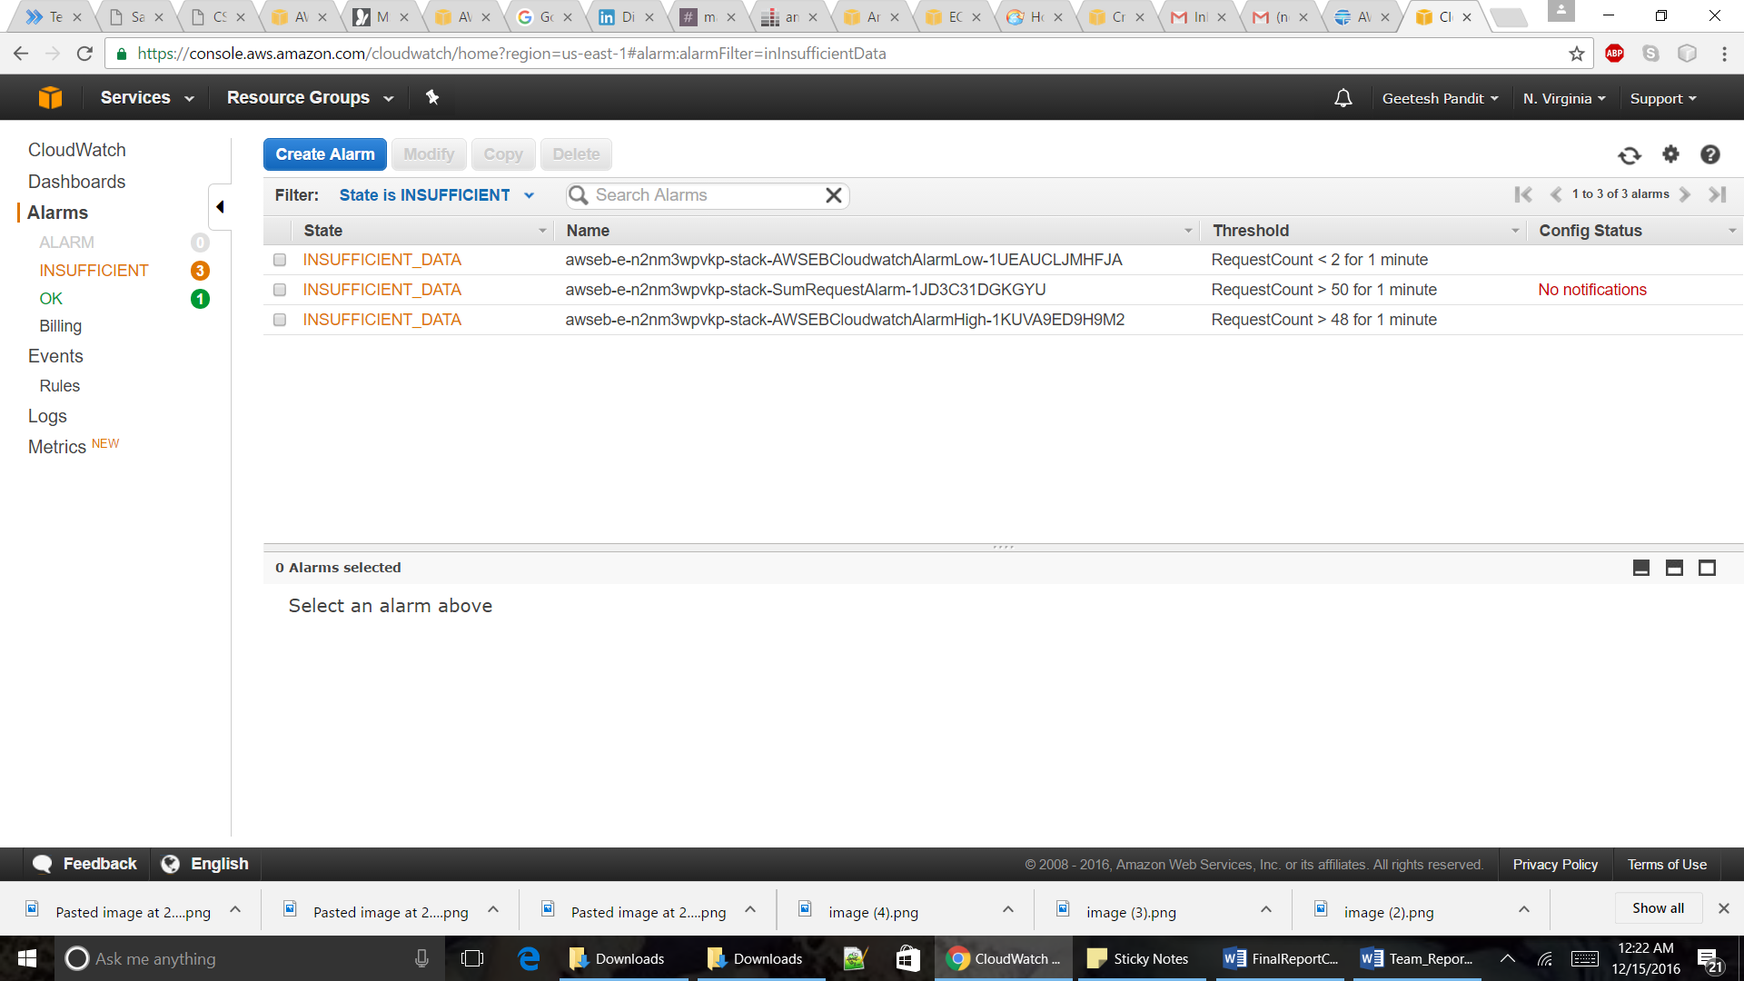

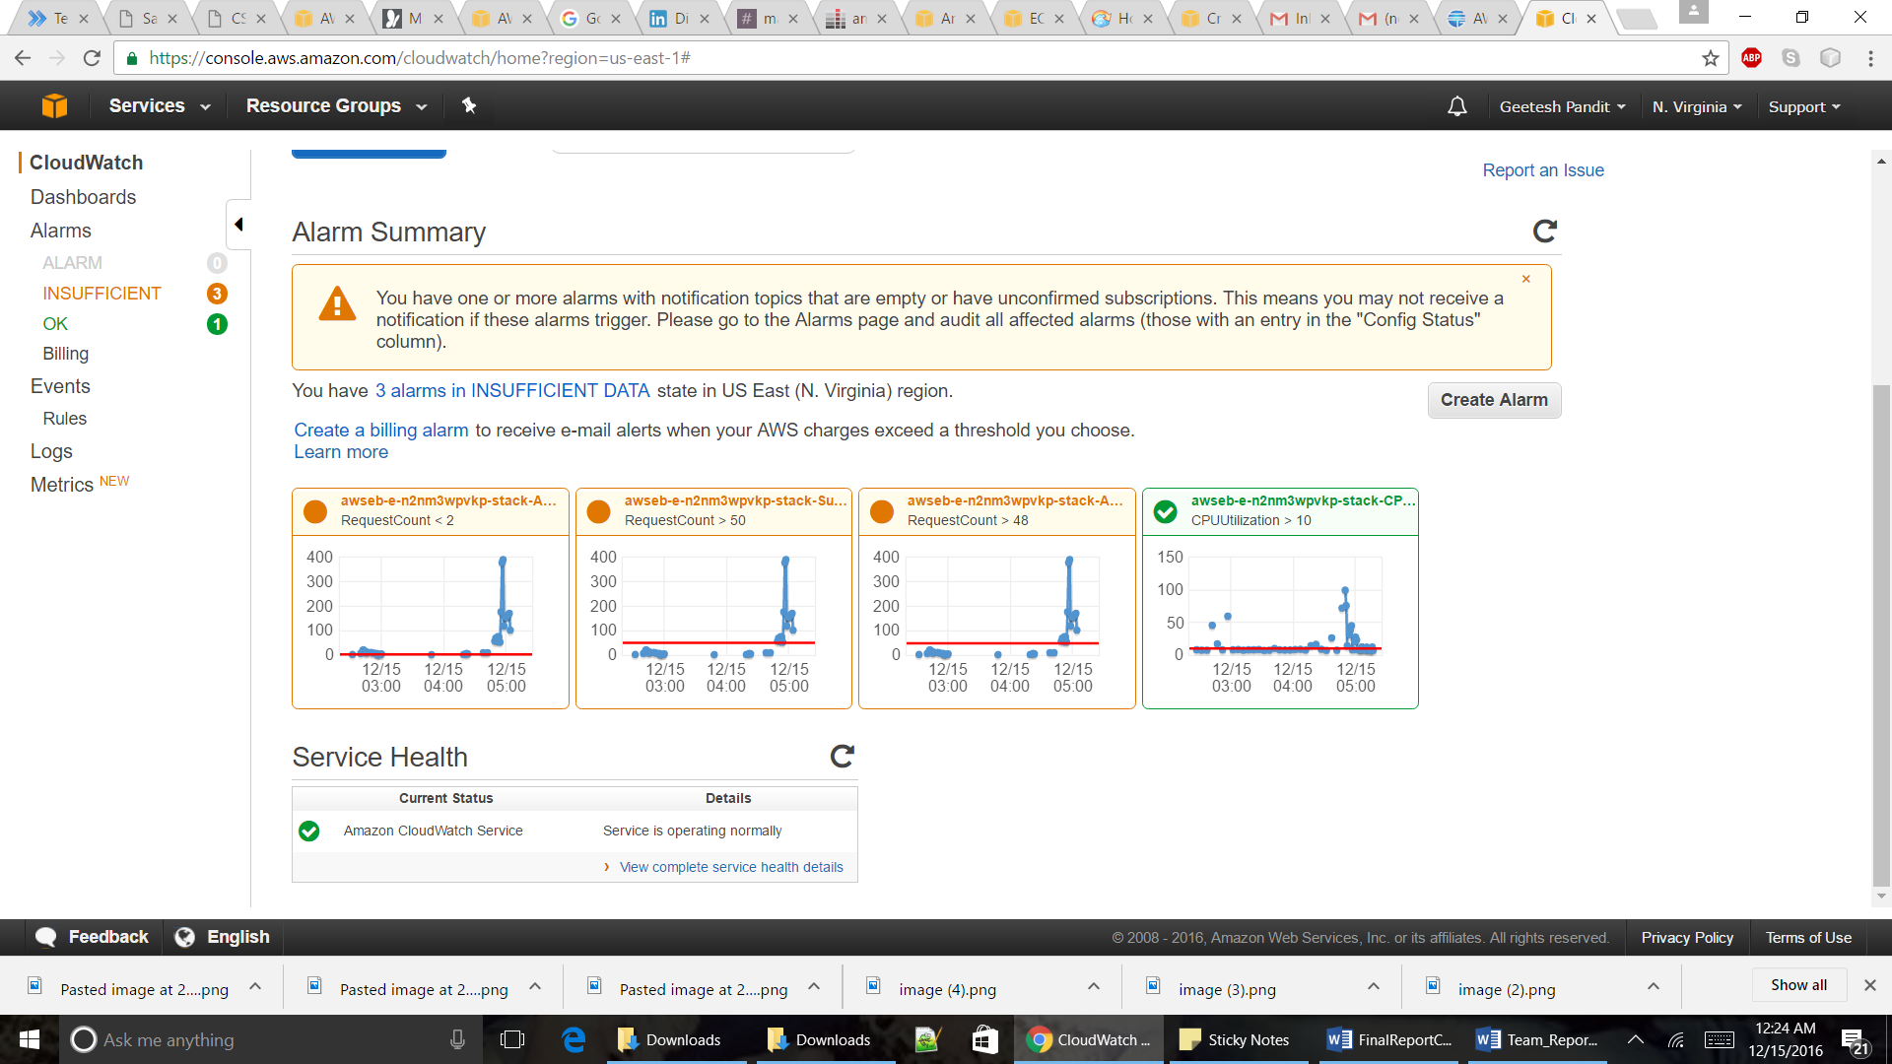

**Use Case Snapshot**

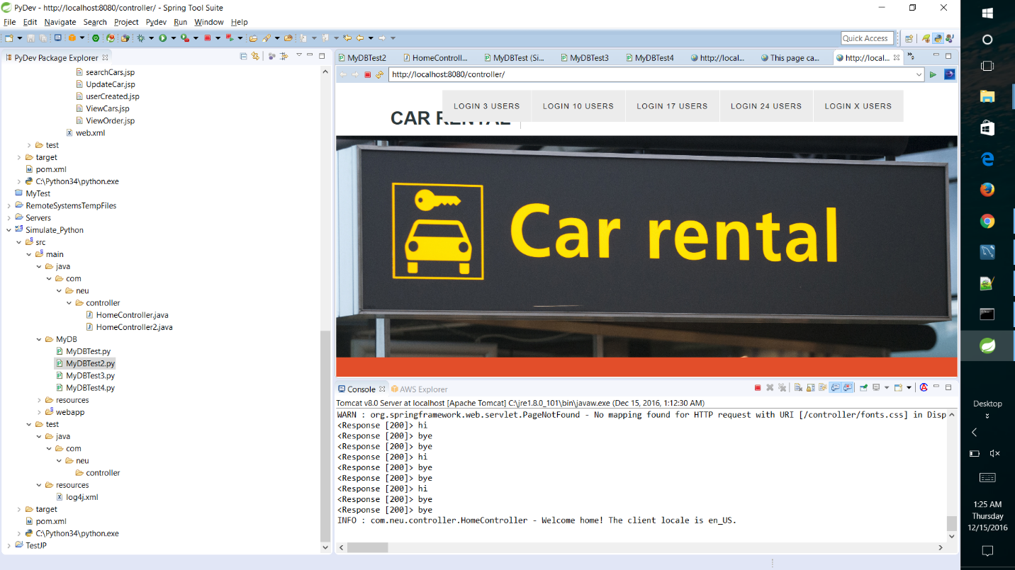

**Cost Pricing model for the next 3-6 months (Cost vs Performance)**

**AWS Simple Monthly Calculator**

Use this tool to estimate your monthly bill, to determine your best and worst case scenarios and identify areas of development to reduce your monthly costs and even compare it with other service providers who do not offer utility-style of billing (pay-as-you-go).

We estimate our application model to cost around $ 65.15 per month to be deployed on AWS by using the AWS Simple Monthly Calculator. So for 3 months it should cost us $195.45

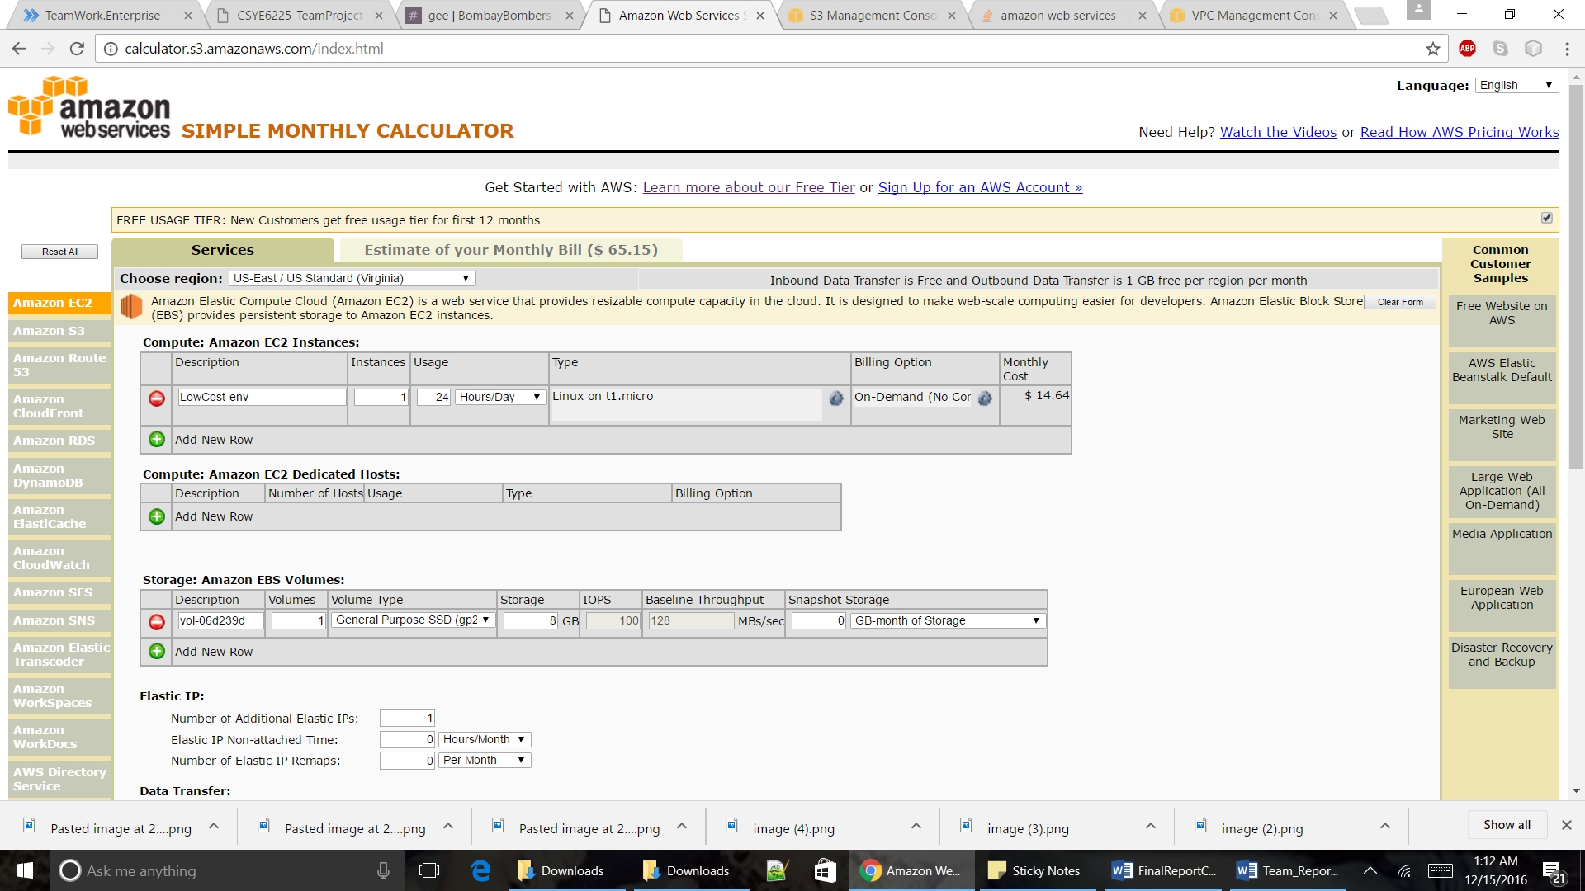

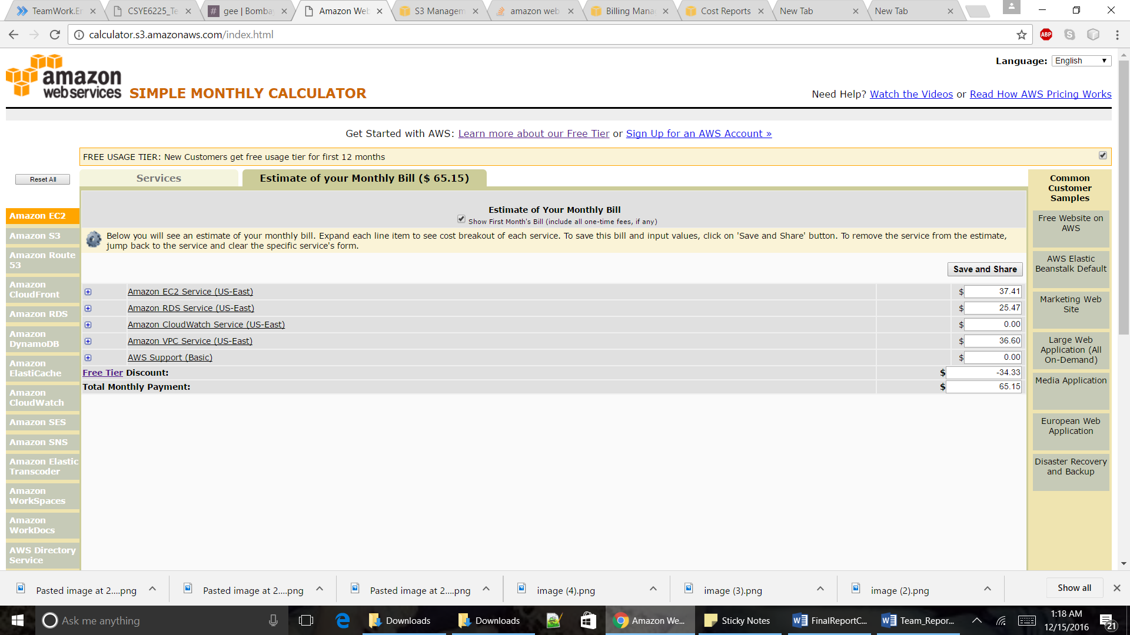

**Cost Explorer** is a free tool that you can use to view graphs of your costs (also known as spend data) for up to the last 13 months, and forecast how much you are likely to spend for the next three months.

Cost Explorer is used to see which service you can use the most, which AZ most of the traffic is in.

Cost Explorer can be used to filter your view by a variety of filters.

**Forecasting with Cost Explorer:**

A forecast is a prediction of how much you will use AWS over the next three months, based on your past usage.

Different ranges of accuracy have different confidence intervals.

For Example, if your budget is set to 100$ and you used 75$ in past 3 weeks. So cost Explorer forecasts that there is an 80% probability that your billed costs will be in the $ 90-100 range, and an 95% probability that your billed costs will be into $ 80-110 range.

**PlotGraph:**   
There are two sets of lines on either side of your costs line. The pair of lines that are closest to the cost line indicate the 80% confidence interval, and the pair of lines that are furthest from the cost line indicate the 95% confidence interval. The wider the range included in the forecast, the higher the probability that your bill will fall in the forecasted range.

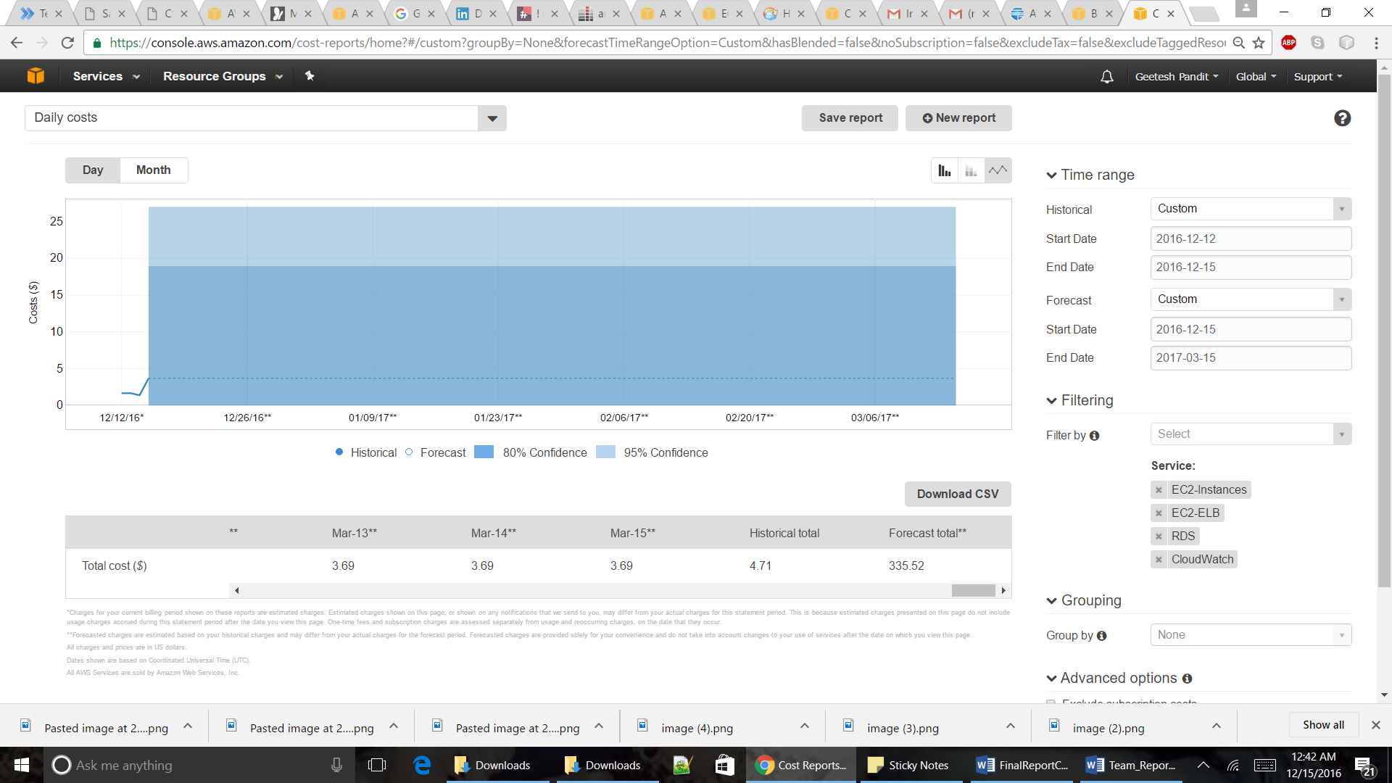

**Bar Graph:**

There are two sets of lines on either side of the top of your bar. The closer darker lines indicate the 80% confidence interval, and the further, fainter lines indicate the 95% confidence interval. The wider the range included in the forecast, the higher the probability that your bill will fall in the forecasted range.

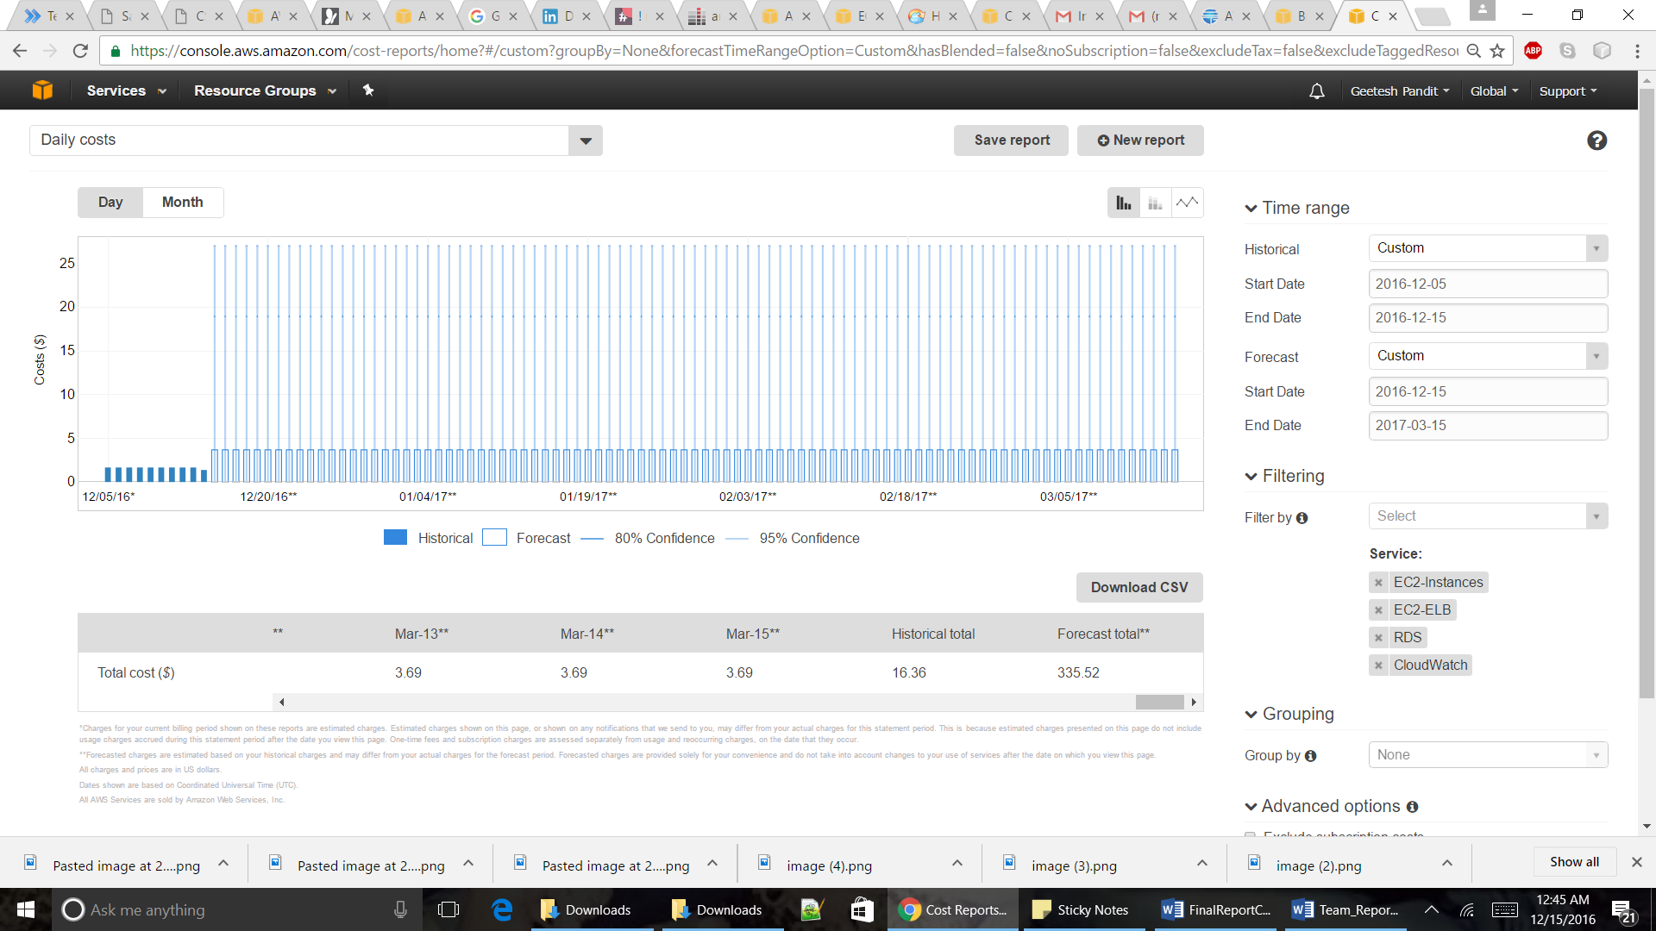

**Visio Diagram and Flow**

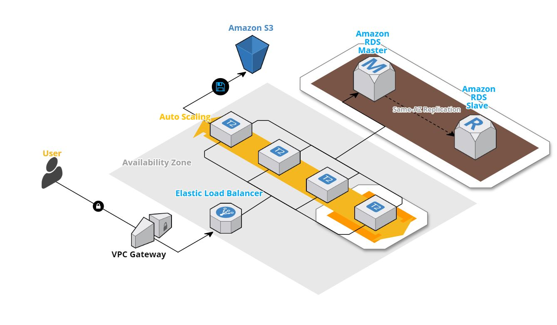

**Visio Diagram and Flow**



**Disaster Recovery Procedures**

* **Preparing for and recovering from a disaster**

hardware or software failure network outage  
power outage   
physical damage   
human error

* **Ensure business continuity during a DR event**   
   full-scale availability  
   fault tolerance systems
* **AWS Services for Disaster Recovery**

Why Disaster Recovery using AWS?

Low cost

Instant Elasticty

Open & flexible

Secure

Regions  
 - Americas, EMEA, and Asia Pacific  
 - Regions consist of one or more Availability Zones.

Storage  
 - Amazon S3:  
 Objects are redundantly stored on multiple devices across multiple facilities within a region, designed to provide a durability of 99.999999999%   
 - AWS Import/Export:  
 AWS Import/Export bypasses the Internet and your data directly onto and off of storage devices by of the high-speed internal network of Amazon.

For data sets of significant size, AWS Import/Export is often faster than Internet transfer and more cost than upgrading your connectivity.

Compute

- Amazon EC2 rapidly create virtual machines that you can control designed to provide a durability of 99.999999999%   
- AMI preconfigure with operating systems and some also include application stacks.

Networking

- Amazon Route 53:  
highly available and scalable Domain Name System (DNS) web service global load balancing capabilities failover between multiple DNS endpoints.

- Elastic IP Address  
Mask instance or AZ failures by remapping public IP address to instances in a particular region pre-allocate some IP addresses for the most critical systems so that their IP addresses are already known before disaster strikes.   
- Elastic Load balancing  
Distributes incoming application traffic Auto Scaling features.  
- Amazon VPC  
Private, isolated section of the AWS cloud as a virtual network Control over.  
 - selection of own IP address range.  
 - creation of subnets.  
 - configuration of route tables and network getaways.

Databases

- Amazon RDS  
Use it to store critical data in preparation phase or store data in recovery.

- AMI preconfigure with operating systems and some also include application stacks.

Deployment orchestration

-Post-startup software installation /configuration.

-Very helpful in the recovery phase, enabling you to create the required set of resources in an automated way.  
-AWS CloudFormation- provision resources in orderly and predictable fashion

Backup and Restore

- Amazon S3 is an ideal destination for backup.  
- Transferring data to and from Amazon S3 is typically done through network, and is therefore accessible from any location.   
- Where retrieval times of several hours are adequate, there is Amazon Glacier.  
- AWS Storage Gateway enables snapshots of your on-premises data volumes to be transparently copied into Amazon S3 for backup.   
- Storage-cached volumes allow you to store your primary data in Amazon S3, but keep your frequently accessed data local for low-latency access.   
- With AWS Storage Gateway, you can snapshot the data volumes to give highly durable backup. In the event of DR, you can restore the cache volumes either to a second site running a storage cache gateway or to Amazon EC2.  
- Back up into Amazon S3   
Snapshots of Amazon EBS volumes, Amazon RDS databases, and Amazon Redshift data warehouses can be stored in Amazon S3.   
you can choose to create backup files and copy those to Amazon S3.

**Disaster Recovery**

**Pilot Light for Quick Recovery into AWS**

* The term pilot light is often used to describe a DR scenario in which a minimal version of an environment is always running in the cloud.
* Our infrastructure has been built on Amazon RDS which allows for having a master and redundant read replica which is on standby.
* We typically have some pre-configured servers bundled as Amazon Machine Images (AMIs)
* Use Elastic IP addresses, which can be pre-allocated and identified in the preparation phase for DR, and associate them with your instances.
* Use Elastic Load Balancing (ELB) to distribute traffic to multiple instances.
* For less critical systems, you can ensure that you have any installation packages and configuration information available in AWS, for example, in the form of an Amazon EBS snapshot. After writing data to an EBS volume, you can periodically create a snapshot of the volume to use as a baseline for new volumes or for data backup. If you make periodic snapshots of a volume, the snapshots are incremental so that only the blocks on the device that have changed after your last snapshot are saved in the new snapshot. Even though snapshots are saved incrementally, the snapshot deletion process is designed so that you need to retain only the most recent snapshot in order to restore the volume. This is saved on Amazon S3.
* Quicker recovery time method because the core pieces of the system are already running and are continually kept up to date
* **Pilot Phase**The following figure shows the preparation phase, in which you need to have your regularly changing data replicated to the pilot light, the small core around which the full environment will be started in the recovery phase. Your less frequently updated data, such as operating systems and applications, can be periodically updated and stored as AMIs.  
  **Recovery Phase**  
  To recover the remainder of the environment around the pilot light, you can start your systems from the AMIs within minutes on the appropriate instance types. For your dynamic data servers, you can resize them to handle production volumes as needed or add capacity accordingly. Horizontal scaling often is the most cost-effective and scalable approach to add capacity to a system. For example, you can add more web servers at peak times. After recovery we again ensure that the redundancy is restored in RDS. You need to have your regularly changing data replicated to the pilot light.

Snapshot created:

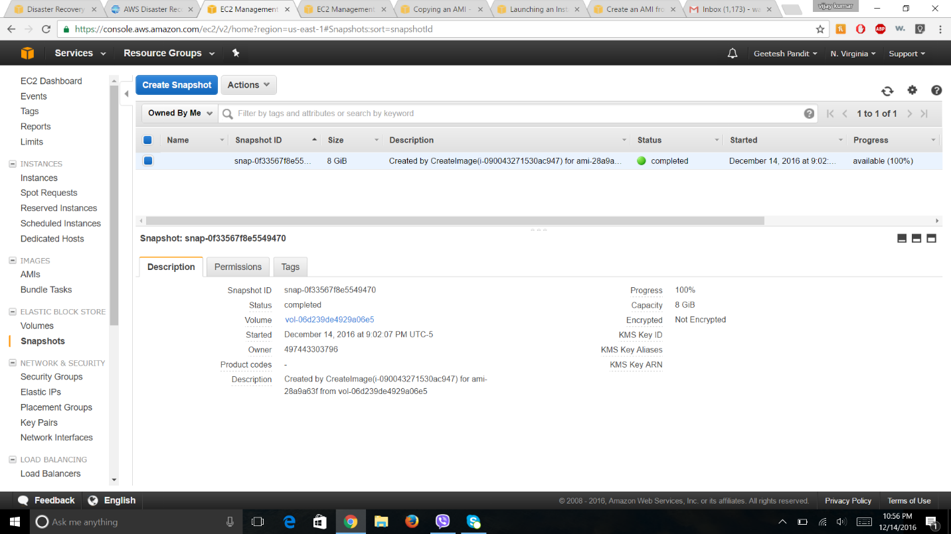

Volume Created:

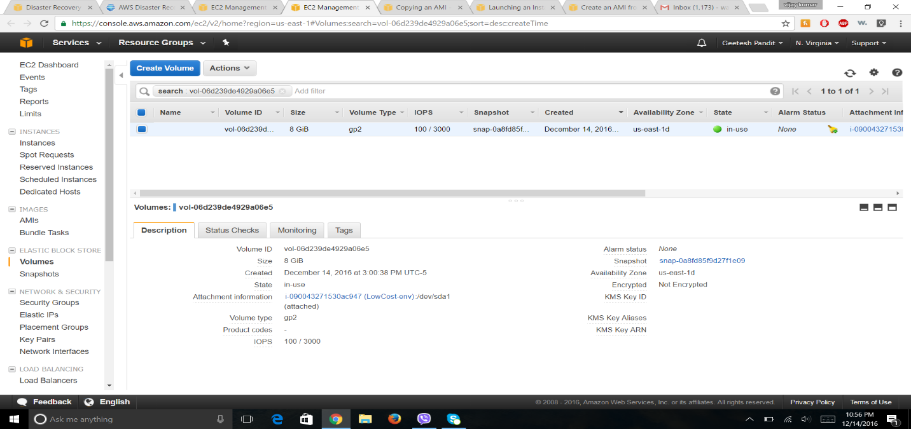

Volume attached to EC2 instance:

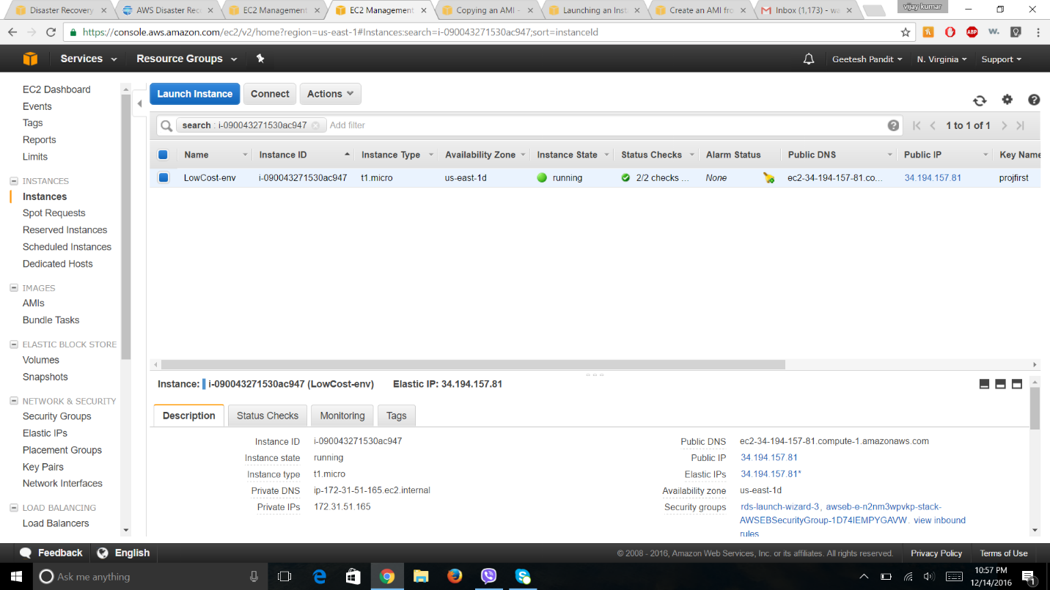

Snapshot added to S3:

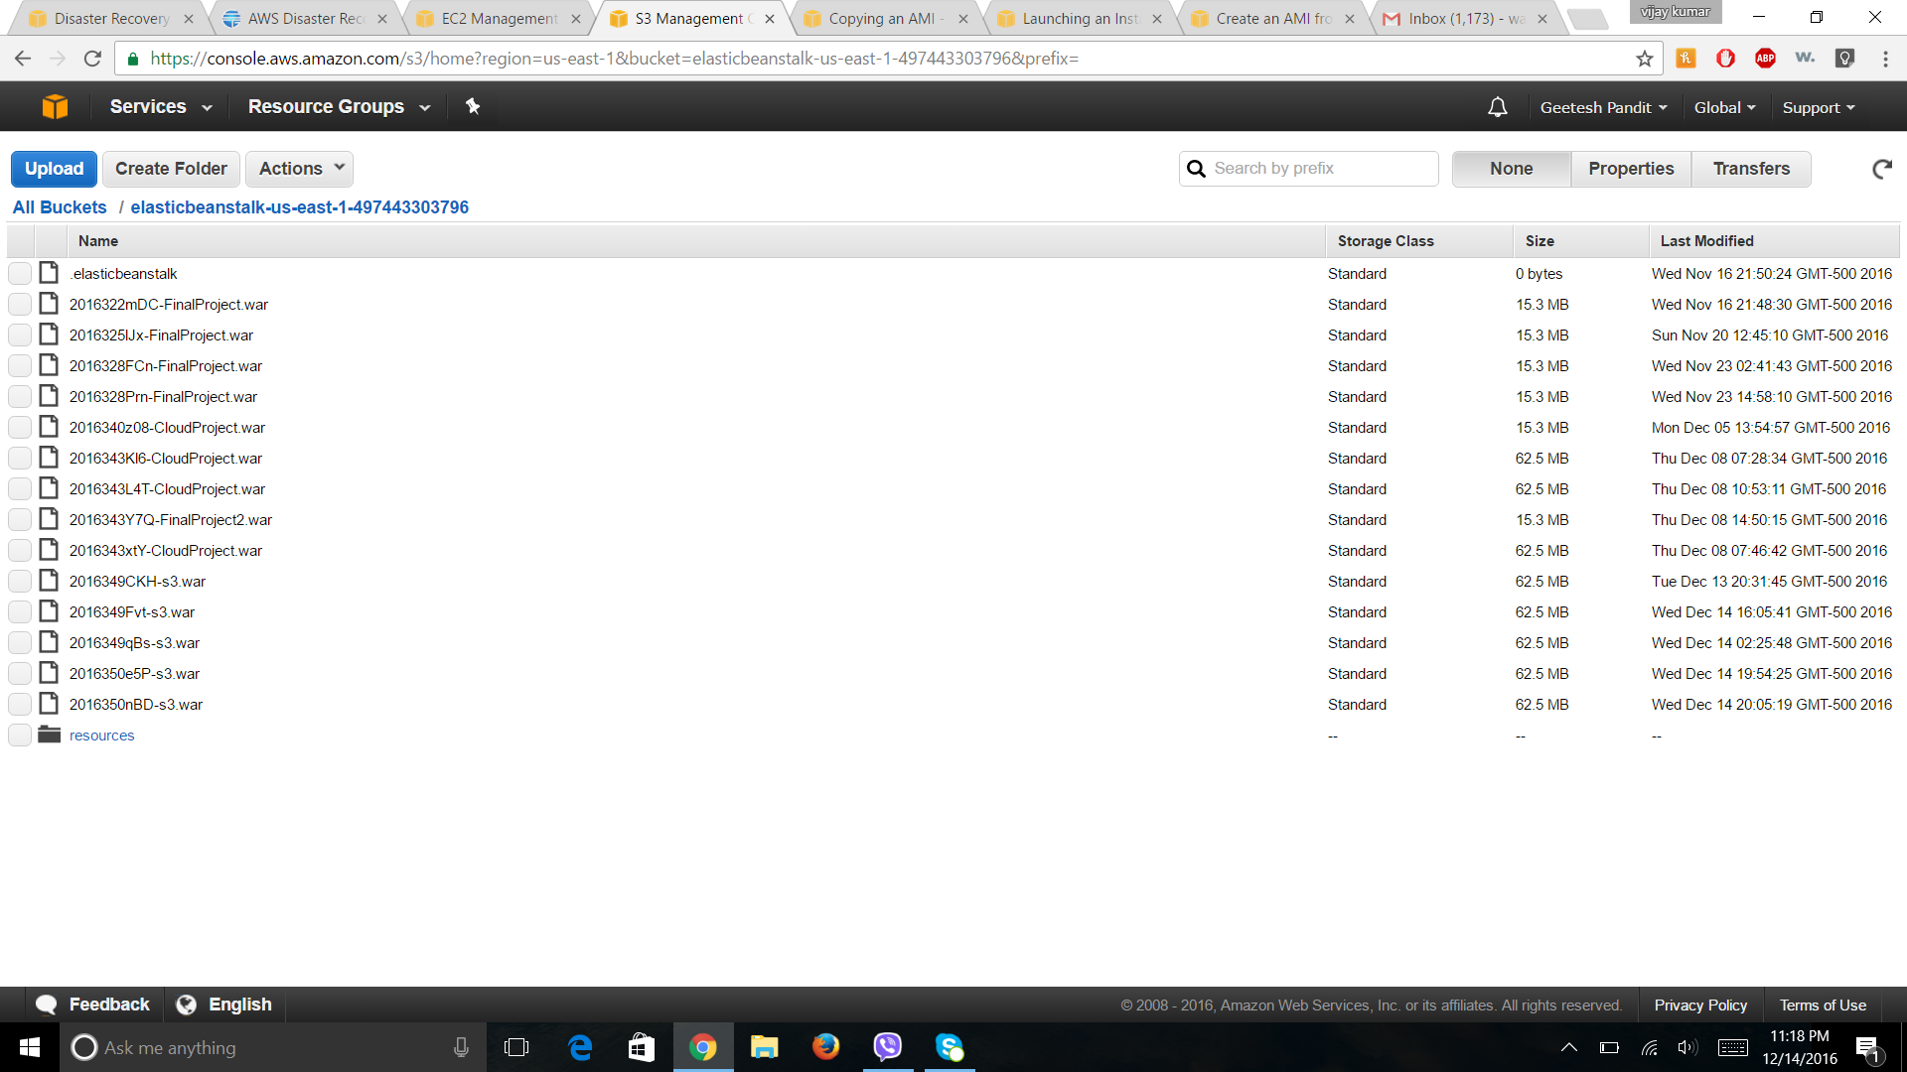

Elastic IP attached to the EC2 instance:

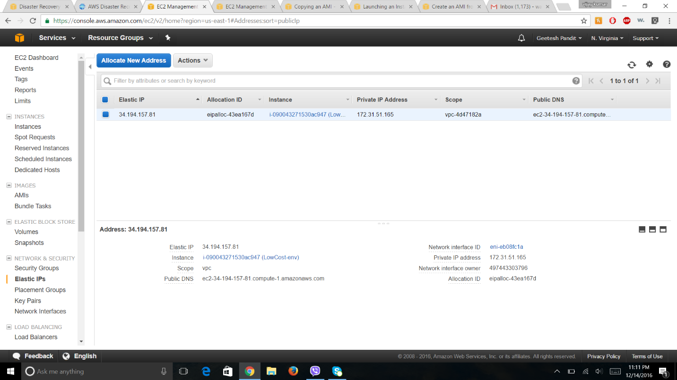

Snapshots of the RDS Db is taken every day.

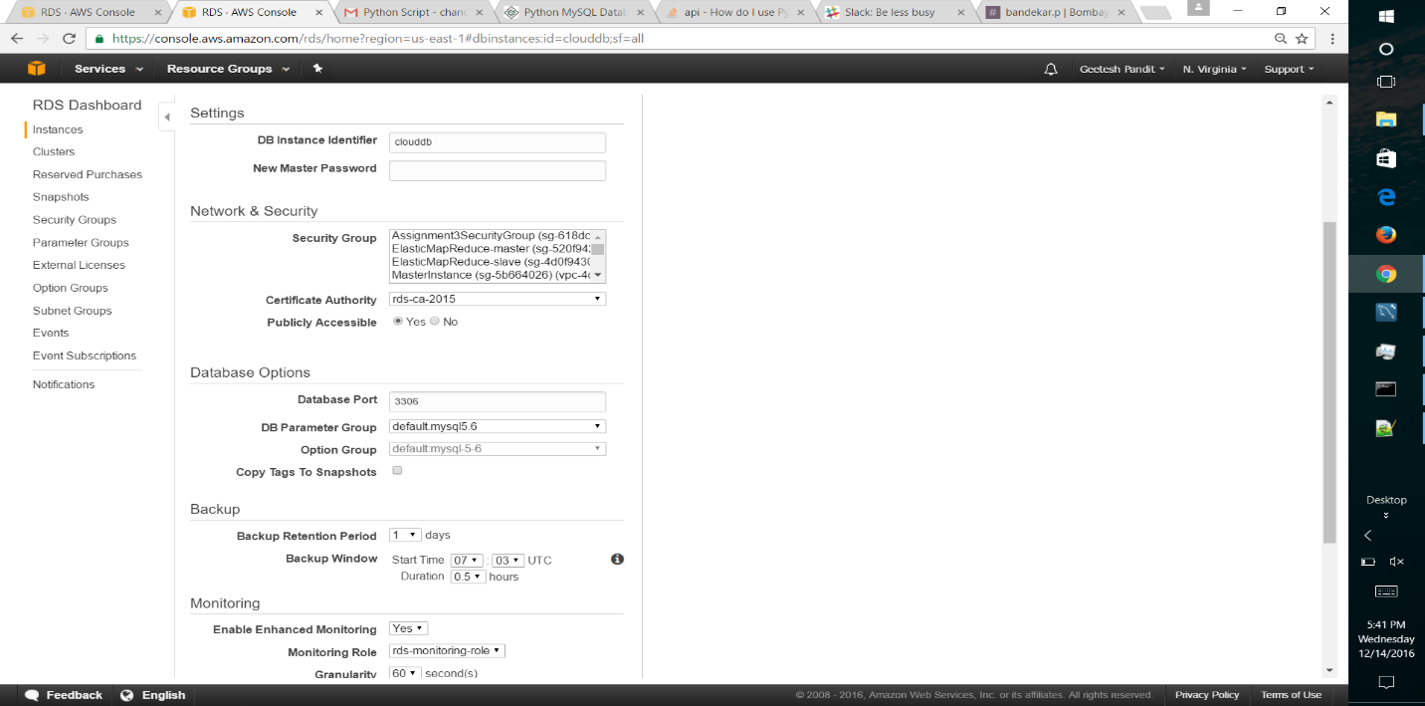

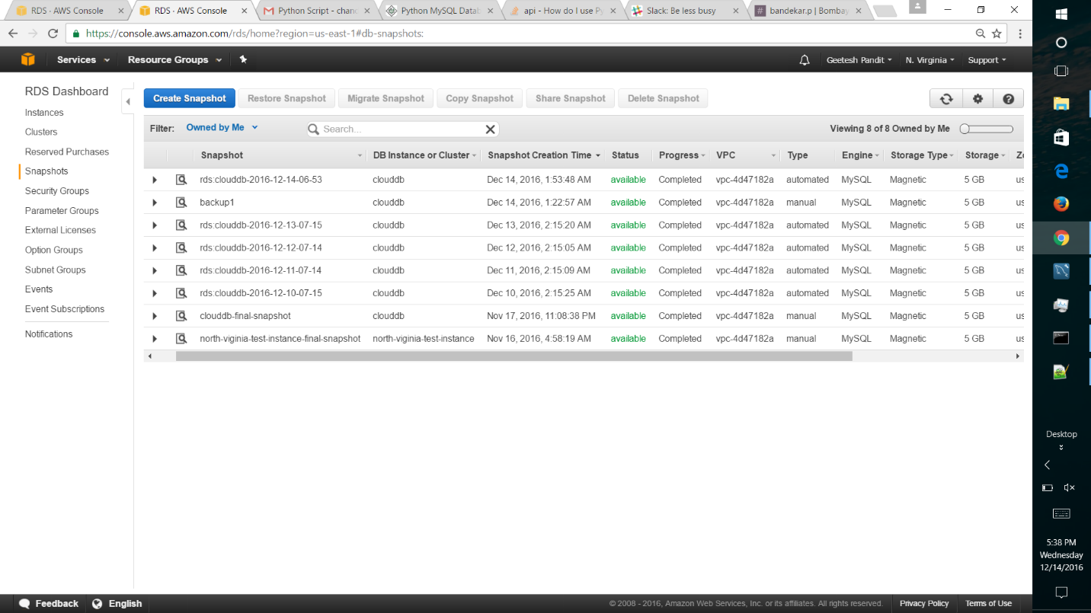

Multi-Availability zone:

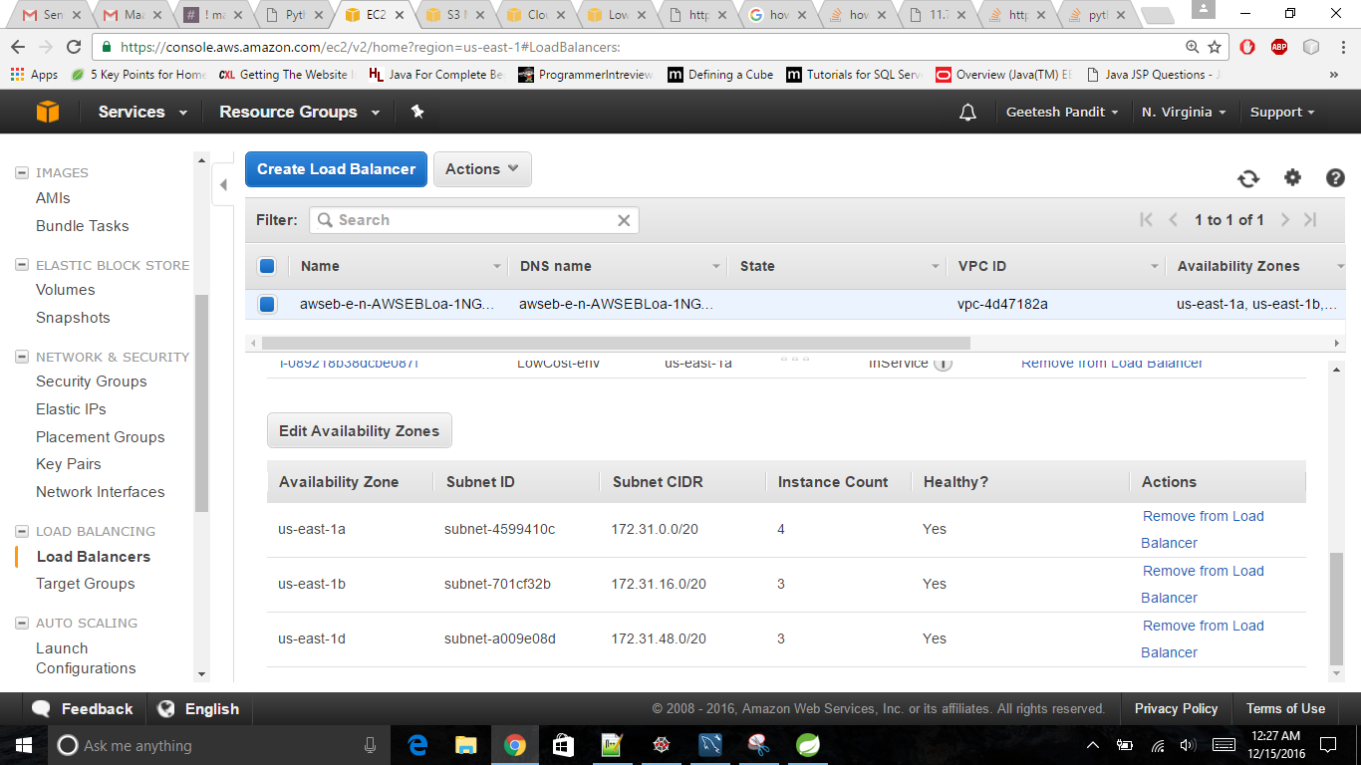

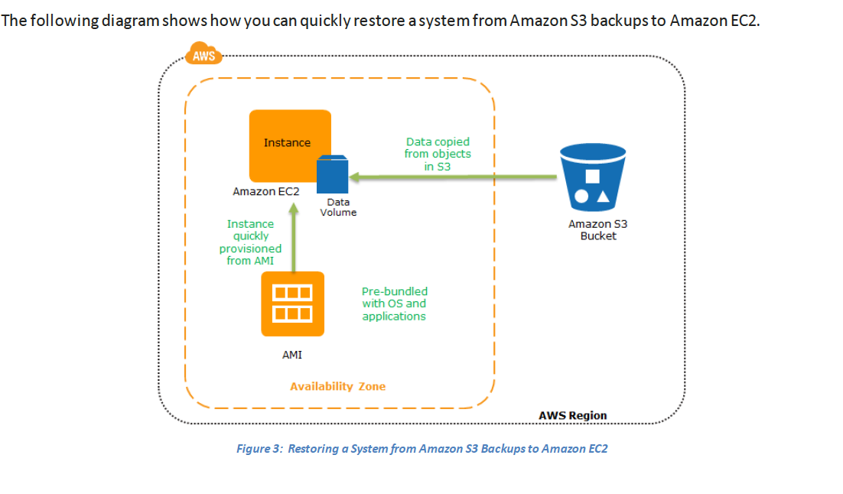

**References**

<https://aws.amazon.com/documentation/>

<https://www.google.com/>

<http://www.ecloudgate.com/Doc/DisasterRecovery_Overview>